**Ganpat University**

**Faculty of Engineering & Technology**

**Computer Science & Engineering**

**2CSE205: Computer Organization**

***Name:- Dwij Vatsal Desai***

***Sem:- 2***

***Sub: - CO***

***Enrollment No.:- 23162121027***

Images:-

🡪8-Bit register

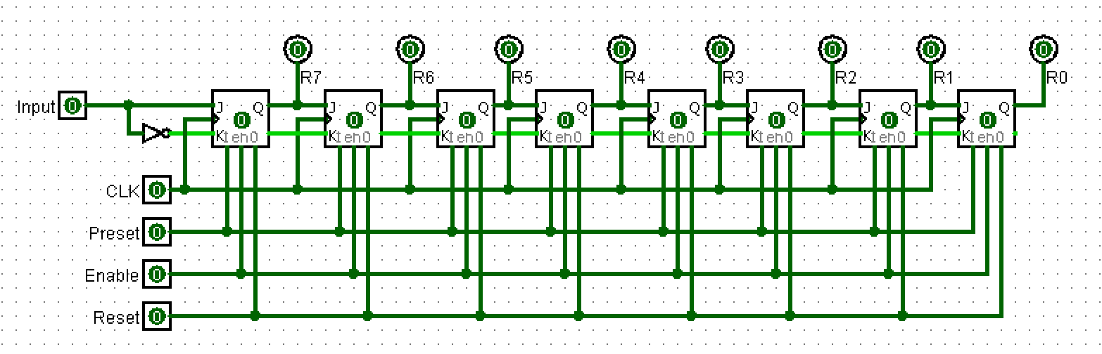

* Final 8-Bit 5 register Bus system

